Catoosa Library Board Meeting
105 East Oak Street
March 28, 2023

NOTICE OF CANCELLATION OF MEETING

The regular monthly meeting of the Catoosa Public Library Board, scheduled for Tuesday, March 28th at 5:00pm is cancelled.

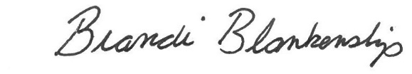
____________________________________
Brandi Blankenship, Director

